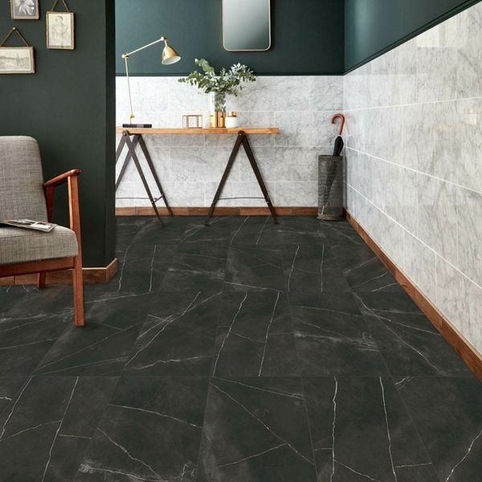**Belgravia Matt Abanilla Marble Effect Tiles:**

## **Product Description**

Inject a luxurious new look into your interiors this season with these gorgeous Belgravia Matt Abanilla Marble Effect Tiles. They have a dark backdrop with light characterful veining. Made from porcelain, they can be used on both walls and floors. They're a large format tile, which gives them a grand appeal, and they have an opulent matt finish.

**What's special about these tiles?**

> Large format design  
> Opulent matt finish  
> Luxurious realistic marble effect look  
> Made from durable porcelain  
> Versatile - perfect for walls and floors  
> Suitable for use with underfloor heating

## **Product INFO**

* Product ID: 39686
* Tiles Per SQM: 1.3888888888889
* Sale by: Per SQM
* Size: 600x1200x10mm
* Weight: 18.84 KG
* Material Type: Porcelain
* Finish: Matt
* Colour: Black/Charcoal
* Suitability: Floors, Walls
* Grade: 4
* Rectified Edge: Yes
* Underfloor Heating: Yes
* Document: [Tile Variations](https://m2.wallsandfloors.co.uk/media/amasty/amfile/attach/39686.pdf),[Tile Variations](https://m2.wallsandfloors.co.uk/media/amasty/amfile/attach/39687.pdf),[Tile Variations](https://m2.wallsandfloors.co.uk/media/amasty/amfile/attach/39688.pdf),[View Layout Designs](https://m2.wallsandfloors.co.uk/media/amasty/amfile/attach/Walls-and-Floors-uffmoor-design-recommendations.pdf)
* Thickness (mm): 10